[Title]
[Author Name]
[Institutional affiliation]
[Email addresses]

Abstract. [About 200 words]

Introduction [Use Style Heading 1]
Reference figures and tables using References > Cross-reference, as I did in Figure 1. Use Zotero to reference the literature. Keep Grammarly running. Use the BodyText style for regular text.
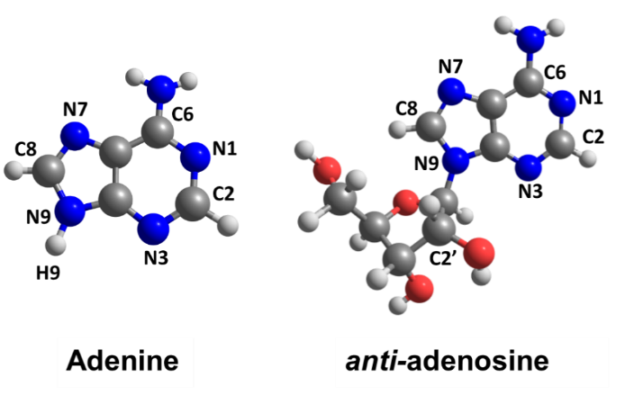
Figure 1. Molecular structures of 9H-adenine and anti-adenosine. If you use figures from another paper, give the reference. [Use References > Insert Captions]

[Section name]
Tables are welcome, see Table 1.
Table 1. Characterization of the four sets of dynamics. [Use References > Insert Captions]
Set | Molecule | T (K) | Number of trajectories starting in
 |  |  | S₁ | S₂ | S₃
1 | adenine | 0 | 10 | 37 | 3
2 | adenosine | 0 | 14 | 32 | 4
3 | adenine | 400 | 10 | 31 | 9
4 | adenosine | 400 | 5 | 22 | 23

[Subsection]
You may want to show some equations
$$F=-\frac{∂E\left(R\right)}{∂R}$$

Acknowledgments
The author thanks the funding provided by [anything?].

References
[Use a reference Style with paper titles.]

